**NVIDIA Certification: DEEP LEARNING FUNDAMENTALS FOR COMPUTER VISION**

**First Task: Image Classification**

Model_1:

Epoch: 20

Learning Rate: 0.0001

Standard Network: AlexNet

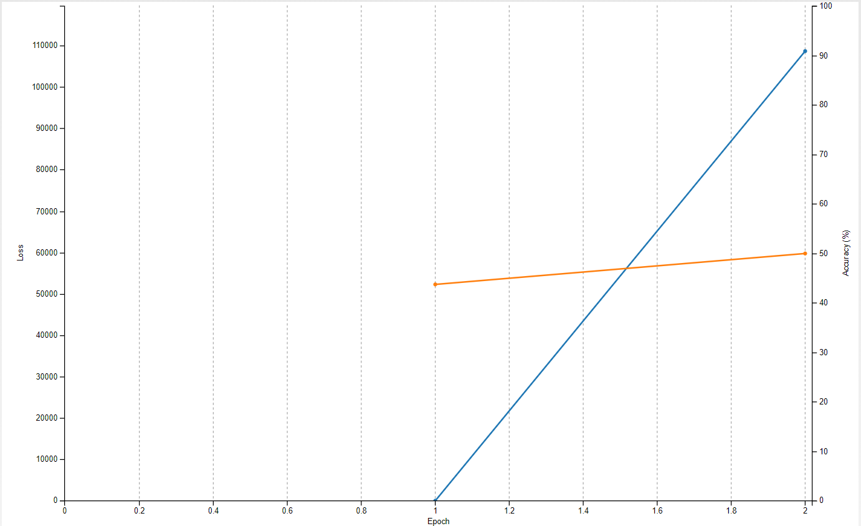

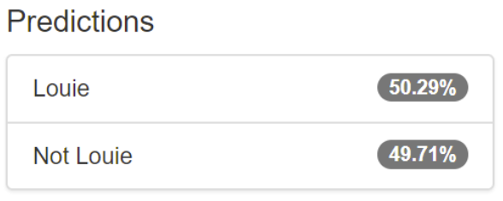

**Comments:** By keeping above hyper-parameters, we can get only 50.29% accuracy which is very low. As mentioned in the certification program, Now I am increasing the number of epochs to 100 and see the results.

Model_2:

Epoch: 100

Learning Rate: 0.0001

Standard Network: AlexNet

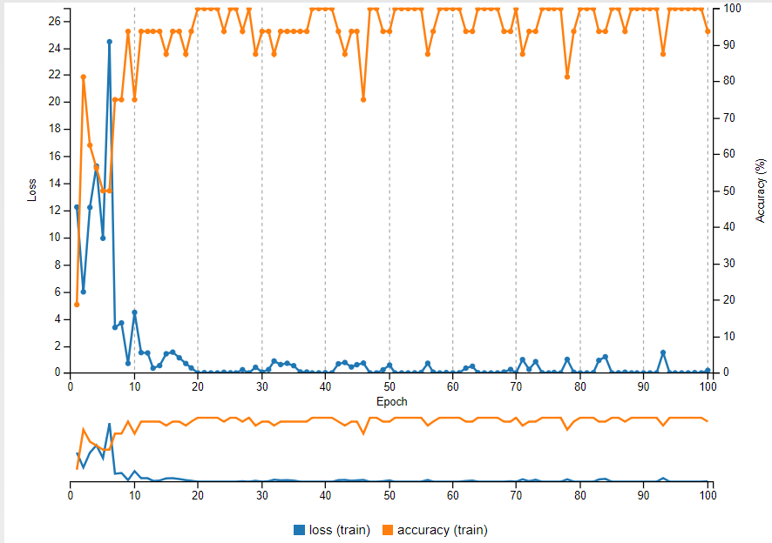

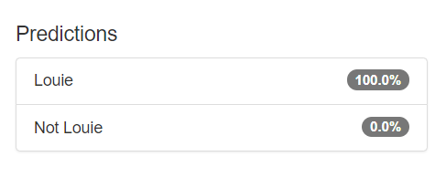

**Comments:** By increasing the number of epochs to 100, We got 100% accuracy. Which means the model can predict exactly which is Louie image.

**Second Task: Image Classification**

A neural network changes when exposed to data to create an accurate map between inputs and outputs. In the Louie example, our model was effective on data from our dataset, but not on any new data, rendering it almost useless in the real world. In this task, we use a new dataset named Images of Dogs and Cats. This dataset contains images of both cats and dogs unlike the first task which had images of only dogs. We make use of Alexnet which we used in the first dataset. Let’s train the model to test the accuracy.

Model_1:

Epoch: 5

Learning Rate: 0.01

Standard Network: AlexNet

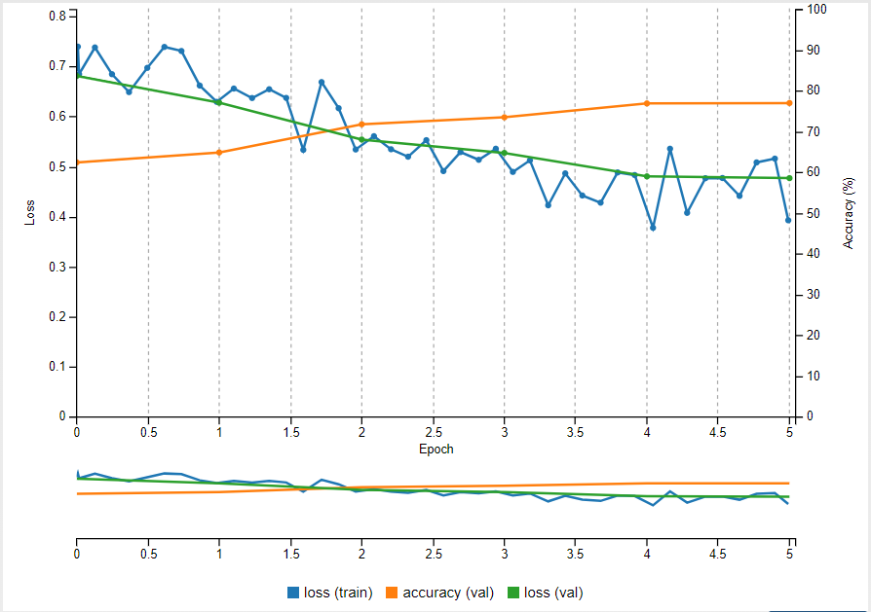

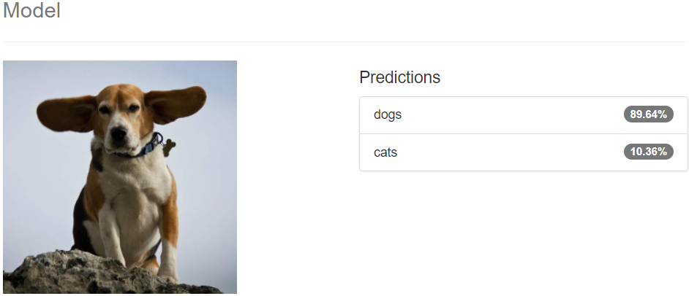

**Comments:** This is the first model that we trained for large dataset and got training accuracy around 79% and we tested random image, it classified it as dog with 89.64% accuracy.

Model_2:

Epoch: 5

Learning Rate: 0.01

Standard Network: GoogleNet

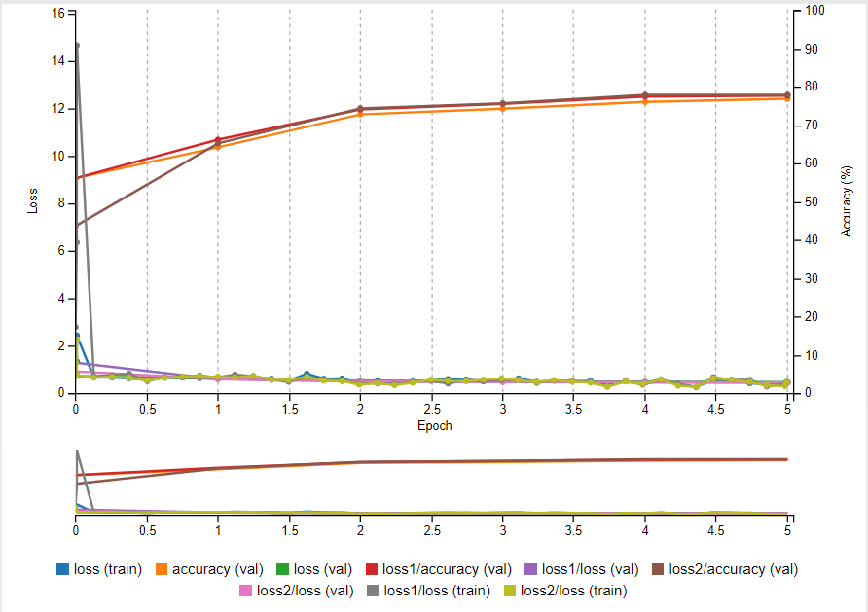

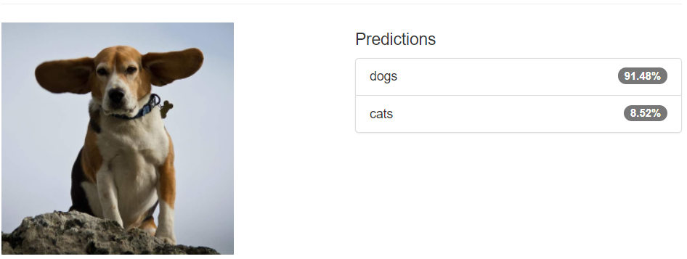

Model_3:

Epoch: 15

Learning Rate: 0.001

Standard Network: AlexNet

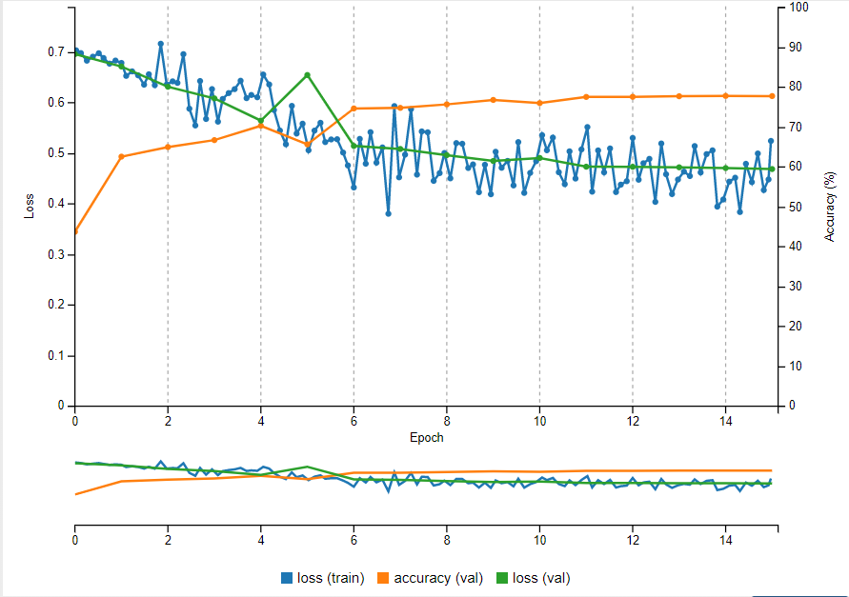

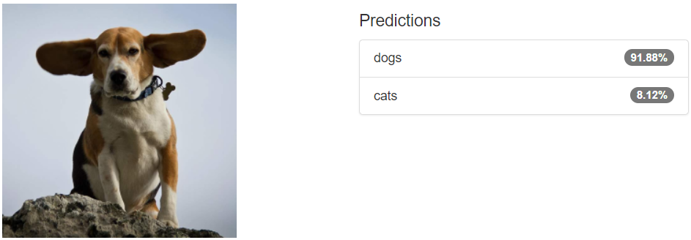

**Third Task:**

* In this task, we make use of the pretrained model which consists of the images of dogs and cats.
* This dataset has a training size of 18750 and a validation size of 6250.We are using the pretrained model which is deployed by making use of model architecture and weights.
* For the previous tasks we have trained a classification model on a smaller dataset and another model on larger dataset and with more number of epochs.
* The objective of this task is to deploy the model we trained previously. The model was used for deployment had weights and architecture of Dog vs cats model.
* We created a simulation to detect if a dog is present at the dog door or not.

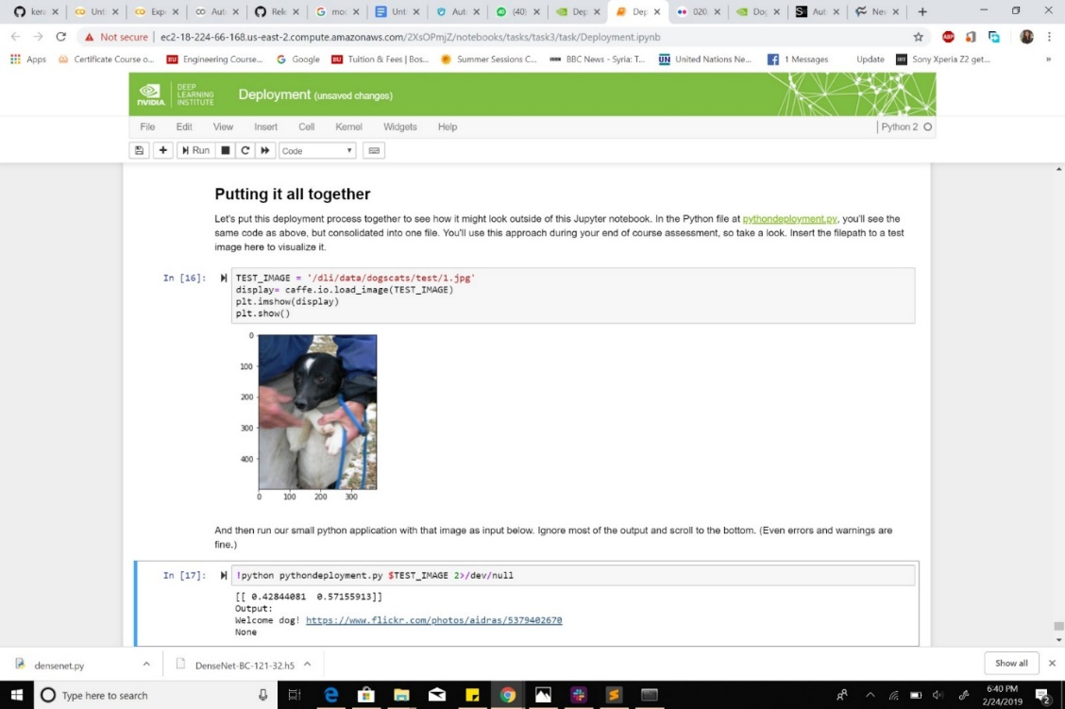

**Fourth Task:**

**Using pretrained model for cats Vs dogs**

Epochs: 8

Learning Rate= 0.0001

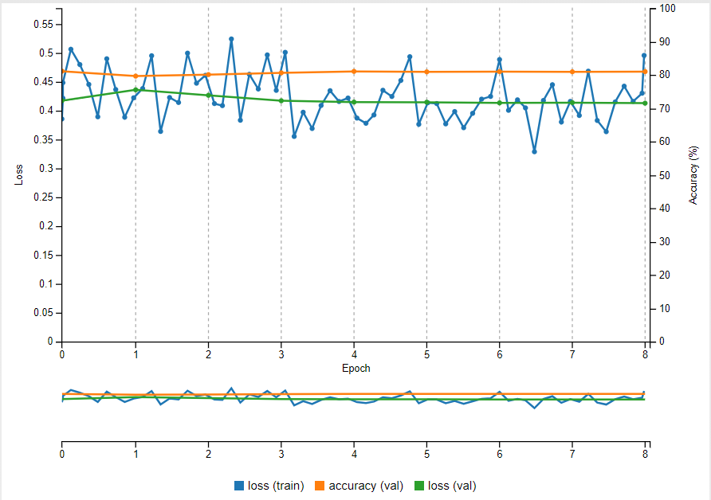

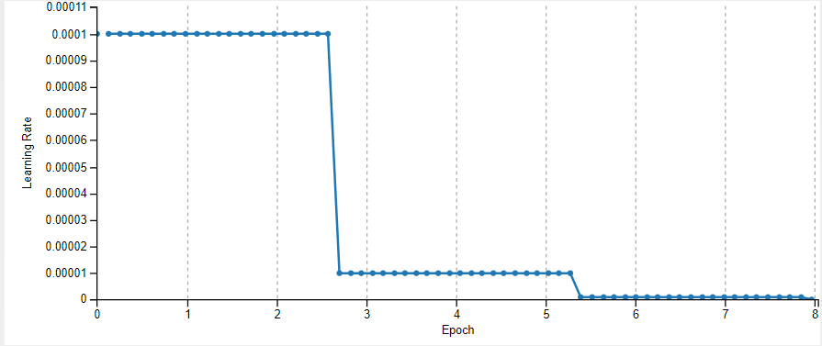

**Fifth Task:**

* Object detection is a computer technology related to computer vision and image processing that deals with detecting instances of semantic objects of a certain class (such as humans, buildings, or cars) in digital images and videos.
* That fact allowed us to build a simple application that harnessed deep learning. In the assessment, we apply the same technique to build something more complex.
* We implement deep learning through the task of image classification. In this section, we'll augment the dataset to expand your definition of deep learning to guide you to see what types of problems can be solved with deep learning and what types can't.
* With image classification, our network took an image and generated a classification. More specifically, our input was a 256X256X3 tensor of pixel values and our output was a 2-unit vector (since we had 2 classes) of probabilities.

**Object Detection Assessment**

* In this task, we used a ‘sliding window’ approach, where we took the small pieces of images which they called grid squares.
* Each grid square ran through an image classifier. The objective was to find Louie in the image. We combined deep learning with traditional computer vision and modified the internal of neural networks.
* We use a total of 3 approaches in this task to perform image detection. In the first approach, we use the traditional network.
* The second approach is rebuilding the existing neural network. The new network was built on the previous network.
* The new network was formed by changing the layer structure from previous AlexNet architecture. DetectNets are used in the third approach. When approach two and three are visualized we can say that the DetectNet is a Fully convolutional network which is configured to produce precise data representations.
* The bulk layers in DetectNet is identical to the GooGLeNet Network. The model was pretrained for 16 hours on NVIDIA Tesla K80.
* Since the model was well trained the DetectNets successfully detected the dog and drew a bounding box around it.

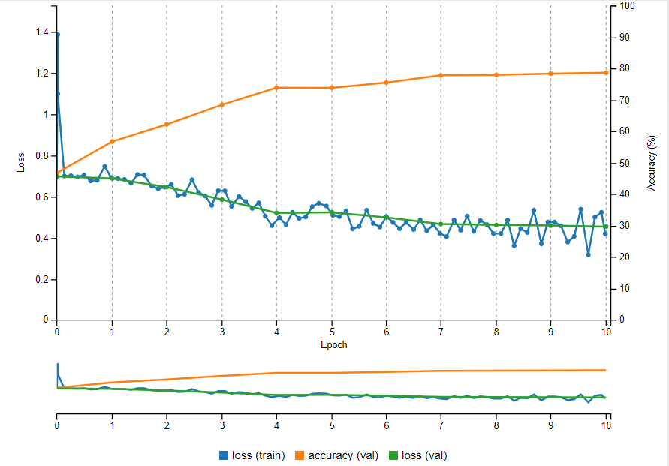

**Assessment Task:**

In the final task of this certification, we are supposed to build a neural network for the given dataset. That data set consists of 2 class of images. We need to build a model whose accuracy should be greater than 80%.

Epoch= 15

Learning Rate= 0.001

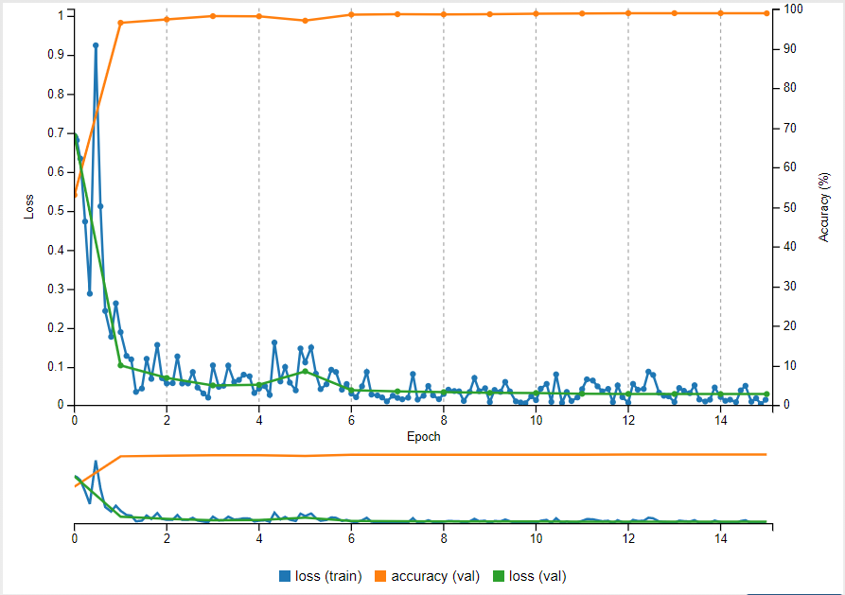

When we built a neural network for the classification problem in assessment, I was able to get nearly 100% accuracy for the model.

Below is the screen shot of classifier which give us result for the input image.

